Session 7
State Management & Interactive Feature Design

Student Name: Guru
Project: Calculator App (Jetpack Compose)
Course: Android / Jetpack Compose Development
Date: March 2026

Section 1: State Concepts Deep Dive

1.1 Key Definitions
State
State is any value or piece of data in an application that can change over time and whose change should be reflected in the UI. In a calculator app, the current number being typed, the selected operator, and the computed result are all examples of state. When state changes in Jetpack Compose, the framework automatically updates the relevant parts of the UI to reflect the new value.
Calculator Example

// State holding the current display value of the calculator
var displayValue by remember { mutableStateOf("0") }

remember()
remember() is a Compose function that stores a value across recompositions. Without remember(), every time a composable recomposes, its local variables would be reinitialised to their defaults, losing any changes the user has made. By wrapping a value in remember { }, Compose retains that value in memory for as long as the composable remains in the composition.
Calculator Example

// Without remember, input would reset to "" on every recomposition
var currentInput by remember { mutableStateOf("") }

mutableStateOf()
mutableStateOf() creates an observable state holder whose value changes trigger recomposition in any composable that reads it. It wraps a plain value in Compose's snapshot state system, which tracks reads and writes automatically. When the value changes, Compose schedules recomposition only for the composables that read that specific state.
Calculator Example

// mutableStateOf wraps the operator string so Compose observes changes
var operator by remember { mutableStateOf("") }
// When operator changes (e.g. from "" to "+"), the UI recomposes

State Hoisting
State hoisting is the pattern of moving state upward to a parent composable, making child composables stateless. The parent owns the state variable and passes both the current value and a callback lambda down to the child. This makes children reusable, independently testable, and easy to preview, because they depend only on their parameters and not on internal state.
Calculator Example

// Parent composable owns the state
@Composable
fun CalculatorScreen() {
var input by remember { mutableStateOf("") }
NumberInput(value = input, onValueChange = { input = it })
}

// Child composable is stateless — receives state and callback
@Composable
fun NumberInput(value: String, onValueChange: (String) -> Unit) {
TextField(value = value, onValueChange = onValueChange)
}

Recomposition
Recomposition is the process by which Jetpack Compose re-executes composable functions when the state they observe changes. Unlike traditional Android Views that required manual calls to update UI, Compose automatically re-runs only the composables that read changed state, skipping everything else. This targeted update mechanism makes the UI both reactive and efficient.
Calculator Example

// result Text recomposes whenever result state changes
var result by remember { mutableStateOf("0") }

Text(text = "Result: $result") // recomposes when result changes
// Other composables on the screen are NOT recomposed

1.2 Interaction Flow — Calculator State Pipeline
The state flow in a calculator app follows a clear, linear pipeline. When the user presses a number button, the onClick lambda appends the digit to the currentInput state variable. Compose detects the state change and recomposes the display Text to show the updated input string. When the user presses an operator button, the selectedOperator state variable is updated and the first operand is saved. When the user presses Equals, a calculate() function reads currentInput and selectedOperator, computes the result, and writes it to the result state variable. Compose then recomposes the result display with the new value, completing the interaction cycle.

Flow: User presses number → currentInput state updates → display Text recomposes → user presses operator → selectedOperator updates → user presses Equals → calculate() runs → result state updates → result Text recomposes.

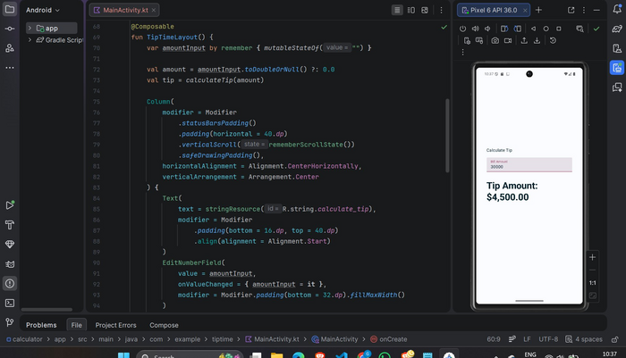
Fig 1a — TipTimeLayout composable: amountInput state declared with remember { mutableStateOf("") }, derived tip calculation, and live Pixel 6 preview showing Tip Amount: $4,500.00
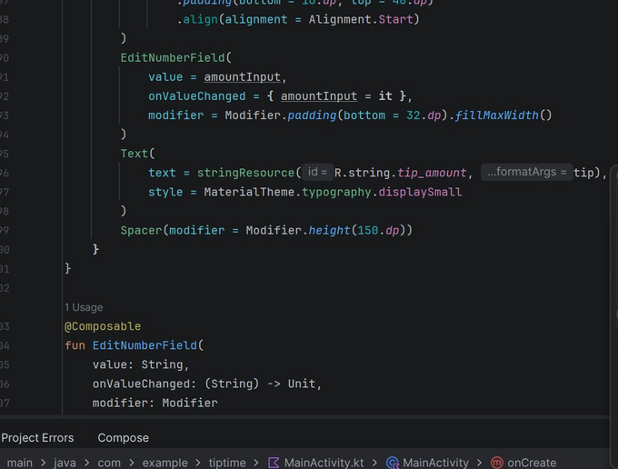
Fig 1b — EditNumberField with state hoisting: value and onValueChange parameters passed from parent; tip_amount Text composable reading derived state

1.3 State Handling Strategy Table
UI Component | State Variable | Stateful / Stateless | Where State is Defined | Comments
Number Buttons | currentInput | Stateful | CalculatorScreen (parent) | Appends digit on each press; triggers display recomposition
Operator Buttons | selectedOperator | Stateful | CalculatorScreen (parent) | Stores +, -, ×, or ÷; cleared after calculation completes
Result Text | result | Stateless | Derived from currentInput + operator | Read-only display; recomposes when result state updates
Clear Button | currentInput, result | Stateful | CalculatorScreen (parent) | Resets all state variables to initial values on press

1.4 Reflection — State Hoisting and State Management
State hoisting is fundamental to writing clean, testable Jetpack Compose code because it enforces a strict separation between UI state and UI presentation. When state lives inside a composable, that composable becomes tightly coupled to its own data, making it impossible to reuse in different contexts or test in isolation. By hoisting state to a parent or ViewModel, child composables become pure functions of their inputs — they display whatever they are given and report user actions via callbacks, making them predictable, previewable, and independently testable. Problems arise quickly when state is not managed correctly: holding state in a non-remembered variable causes it to reset to its default on every recomposition, creating a confusing UI that appears to ignore user input. Storing state too deep in the composable tree leads to duplicated state across siblings, causing inconsistencies where two components show different values for the same data. Mutating collections in place instead of replacing them with new copies prevents Compose from detecting changes, leading to stale UI that does not update even though the underlying data has changed. In a calculator app specifically, incorrect state management could result in the display showing the wrong input, operators being applied to the wrong operands, or results persisting incorrectly after the user presses Clear.

Section 2: Input, Validation & UI Feedback Plan

Feature Scenario: A Calculator application where users enter numbers, choose operators (+, -, ×, ÷), and see calculated results displayed in real time. The app must validate user input, handle edge cases such as division by zero, and provide clear feedback when invalid operations are attempted.

2.1 Input Fields and State Variables
Input Component | State Variable | Validation Rule
Number Input | numberInput | Must be numeric; non-numeric characters are rejected. Input must not be empty before an operator can be applied.
Operator Button | operator | An operator must be selected before the Equals button is enabled. A second operator press replaces the first without calculating.
Equal Button | result | Calculates the expression from numberInput and operator. Disabled if numberInput is empty. Division by zero triggers an error message instead of a result.

2.2 UI Feedback Plan
Validation Rule | UI Feedback
Invalid number input | Show a red error Text below the input field: "Please enter a valid number." The Equals button is disabled until the input is corrected.
Division by zero | Display "Cannot divide by zero" in the result area using an error colour (red). Log the event and reset the operator state to prevent further invalid calculations.
Empty input | The Equals button is visually disabled (reduced opacity, non-interactive) using Compose's enabled = false parameter. No calculation is attempted.
Successful calculation | The result is displayed in large bold Text in the result area. The input field is cleared and awaits the next number entry.

2.3 Calculator Screen Wireframe Description
The calculator screen uses a vertically stacked Column layout with the following regions from top to bottom:
- Top — Result Display: A large Text composable showing the current input or computed result. Uses a dark background with white text for strong contrast, styled like a traditional calculator display.
- Upper Middle — Input Area: A TextField or a row of number button presses that builds the input string. Shows validation error messages directly below when input is invalid.
- Middle — Number Buttons (0–9): Arranged in a 3×4 grid using LazyVerticalGrid or nested Rows. Each button appends its digit to the currentInput state on press.
- Bottom — Operator Buttons (+, -, ×, ÷, =, C): A Row of styled buttons. Operator buttons update selectedOperator state. The Equals button triggers calculation. The Clear button resets all state to initial values.

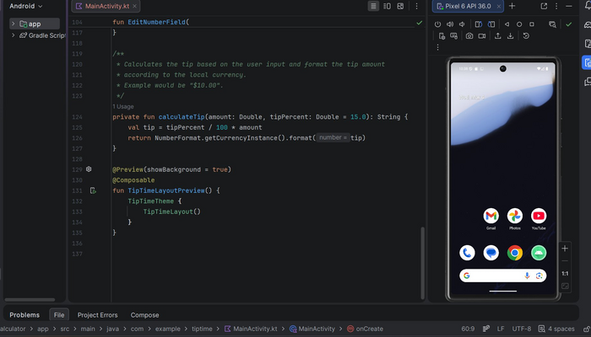
Fig 2a — calculateTip() private function and TipTimeLayoutPreview composable; Pixel 6 emulator home screen visible in preview panel
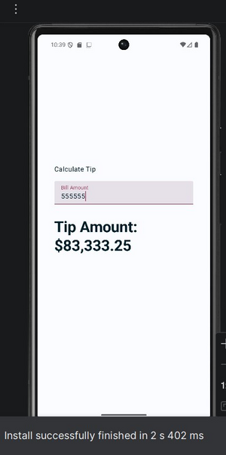
Fig 2b — Pixel 6 emulator home screen (left) and Calculator/Tip app running with bill amount 555555 showing Tip Amount: $83,333.25 (right)

2.4 Reflection — Importance of Validation and UI Feedback
Validation and UI feedback are not cosmetic additions — they are essential quality requirements for any interactive application. Without input validation, a user entering letters instead of numbers, or attempting to divide by zero, would cause the app to crash or display meaningless results, immediately eroding trust. Clear UI feedback ensures that users always understand the current state of the application: they know whether their input is valid, whether a calculation is possible, and what the outcome of their action was. In Jetpack Compose, validation is naturally integrated into the state model — by gating the Equals button behind an enabled = currentInput.isNotBlank() condition, the UI automatically reflects the validity of the input without any manual view updates. Providing specific error messages such as 'Cannot divide by zero' is far more helpful than a generic crash or silent failure, guiding the user toward the correct action. Finally, consistent feedback patterns — such as using red for errors, green for success, and disabled styling for unavailable actions — create an intuitive visual language that reduces the learning curve and makes the app accessible to a wider audience.

Section 3: Comprehensive Feature Design & Implementation Strategy

Feature Name: Simple Calculator with Stateful UI
Feature Description: A calculator app where users input numbers and operators to perform arithmetic operations. The UI updates dynamically based on user interactions and state changes, with input validation and clear error handling for edge cases.

3.1 Layout Description
- Display Screen — A Text composable at the top showing the current input string and computed result. Styled with large, bold typography against a contrasting background.
- Number Buttons — Ten buttons (0–9) arranged in a grid layout. Each press appends the corresponding digit to the currentInput state variable.
- Operator Buttons — Four operator buttons (+, -, ×, ÷) that store the selected operation in the operator state variable and save the first operand.
- Equals Button — Triggers the calculate() function using currentInput and operator, writes the result to the result state, and clears the input for the next operation.
- Clear Button — Resets currentInput, operator, and result back to their initial values, returning the app to its starting state.

3.2 Button Actions Table
Button | Action | State Variable Affected
Number Buttons (0–9) | Append pressed digit to the current input string | currentInput
Operator Buttons | Store selected operator; save currentInput as first operand | operator, firstOperand
Equals (=) | Run calculate() with stored operands and operator; write result | result
Clear (C) | Reset all values to initial state | currentInput, operator, result

3.3 State Model
State Variable | Type | Initial Value
currentInput | String | "" (empty string — no digits entered yet)
firstOperand | Double | 0.0 (holds the first number before operator is pressed)
operator | String | "" (empty — no operator selected)
result | String | "0" (default display value shown on app launch)

3.4 Pseudocode

// ── State variables ───────────────────────────────────────────────
var currentInput by remember { mutableStateOf("") }
var firstOperand by remember { mutableStateOf(0.0) }
var operator by remember { mutableStateOf("") }
var result by remember { mutableStateOf("0") }

// ── Number button (example: "5") ──────────────────────────────────
Button(onClick = { currentInput += "5" }) { Text("5") }

// ── Operator button (example: "+") ──────────────────────────────
Button(onClick = {
firstOperand = currentInput.toDoubleOrNull() ?: 0.0
operator = "+"
currentInput = ""
}) { Text("+") }

// ── Equals button ────────────────────────────────────────────────
Button(
onClick = { result = calculate(firstOperand, currentInput, operator) },
enabled = currentInput.isNotBlank()
) { Text("=") }

// ── Clear button ─────────────────────────────────────────────────
Button(onClick = {
currentInput = ""; operator = ""; result = "0"; firstOperand = 0.0
}) { Text("C") }

// ── Result display ────────────────────────────────────────────────
Text(text = if (currentInput.isNotEmpty()) currentInput else result)

// ── Calculate helper ─────────────────────────────────────────────
fun calculate(a: Double, bStr: String, op: String): String {
val b = bStr.toDoubleOrNull() ?: return "Invalid input"
return when (op) {
"+" -> (a + b).toString()
"-" -> (a - b).toString()
"x" -> (a * b).toString()
"/" -> if (b == 0.0) "Cannot divide by zero" else (a / b).toString()
else -> "Error"
}
}

3.5 Test Cases
Test Case 1 — Basic Addition
Input: Press 5, then +, then 5, then =
Expected Result: Result display shows '10'. currentInput clears and result state is updated to '10'.

Test Case 2 — Division by Zero
Input: Press 1, then 0, then ÷, then 0, then =
Expected Result: Result display shows 'Cannot divide by zero' in red. No crash occurs. The operator and input state are reset so the user can start a new calculation.

Test Case 3 — Multiplication
Input: Press 8, then ×, then 7, then =
Expected Result: Result display shows '56'. State updates correctly: firstOperand = 8.0, operator = '×', currentInput = '7', result = '56'.

3.6 Scaling Considerations
Scientific Functions
The calculate() function can be extended with additional operator cases (sin, cos, log, sqrt) using Kotlin's kotlin.math library. A mode toggle state variable would switch the UI between basic and scientific layouts, showing an expanded grid of function buttons when enabled.
History of Calculations
A List<String> state variable (hoisted to a ViewModel) can accumulate each completed calculation expression and result. A LazyColumn composable would display the history scrollably below the main calculator, with a clear history button to reset the list.
Persistent Storage
Calculation history and user preferences (such as angle mode or default tip percentage) can be persisted using the DataStore Preferences API, which integrates cleanly with Compose's collectAsStateWithLifecycle() to make persisted settings observable. Room database can store detailed calculation records if a full history feature is required.

3.7 Reflection — Planning State Management and Compose's Role
Planning the state management for a calculator app revealed how important it is to identify all pieces of mutable data before writing any code. The most significant challenge was deciding how to handle the two-operand flow: the first number must be saved when the operator is pressed, but it should not overwrite the display until the second number is entered. This required introducing a separate firstOperand state variable, which was not obvious from the initial feature description. Another challenge was determining when the display should show currentInput versus the result — implementing an if/else in the Text composable made this logic explicit and easy to test. Jetpack Compose's reactive state model was invaluable throughout this process: by modelling each piece of the calculator's data as a mutableStateOf variable, the UI automatically stayed in sync with the application logic without any manual view updates, eliminating an entire category of bugs common in imperative View-based code. The remember() API ensured state survived recompositions triggered by keyboard appearance and device rotation. The most important lesson was that Compose rewards upfront clarity about what the state is and where it lives — apps designed with clean state models are far easier to extend with features like history, undo, and persistent storage than apps where state is scattered across multiple composables without a coherent ownership model.

